Assignment Master SQL

1. Start by querying all of the data from heroes_information if the Race has an average weight of over 400.

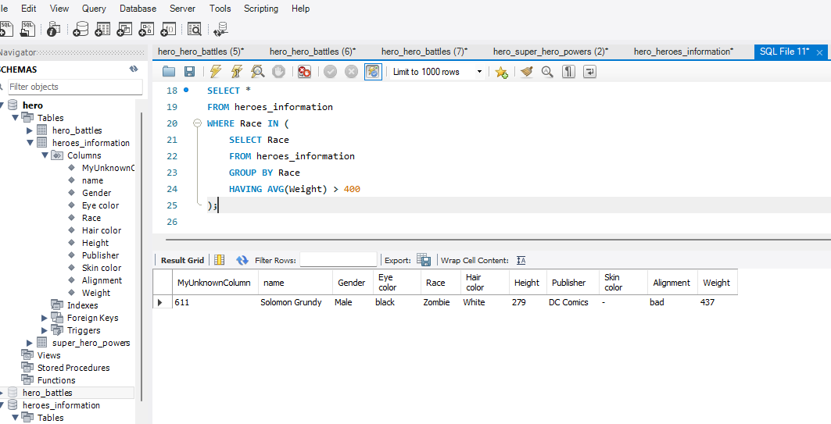

2 Create a temporary table for this result called bigs

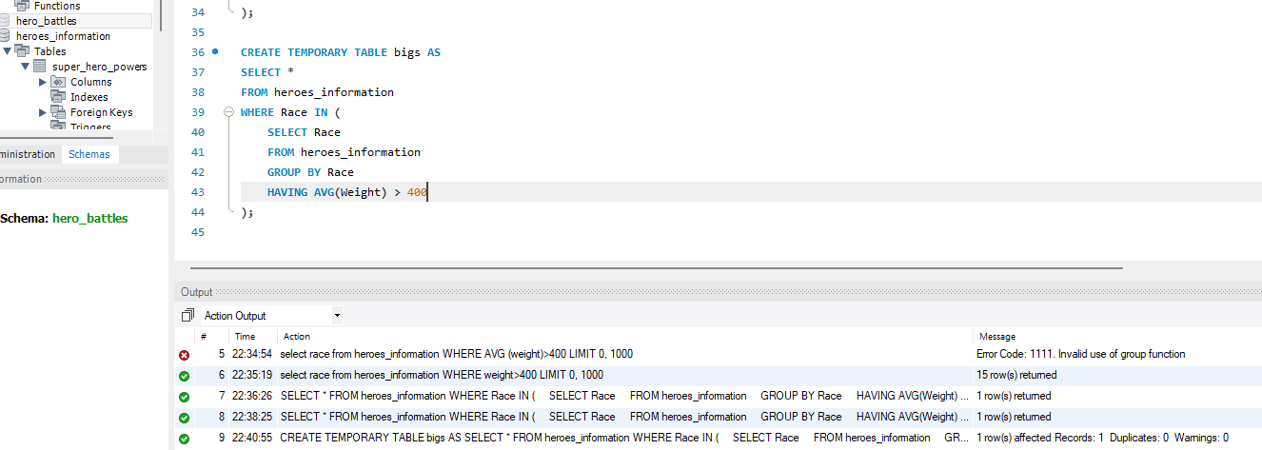

3 Select all columns and rows from that temporary table.

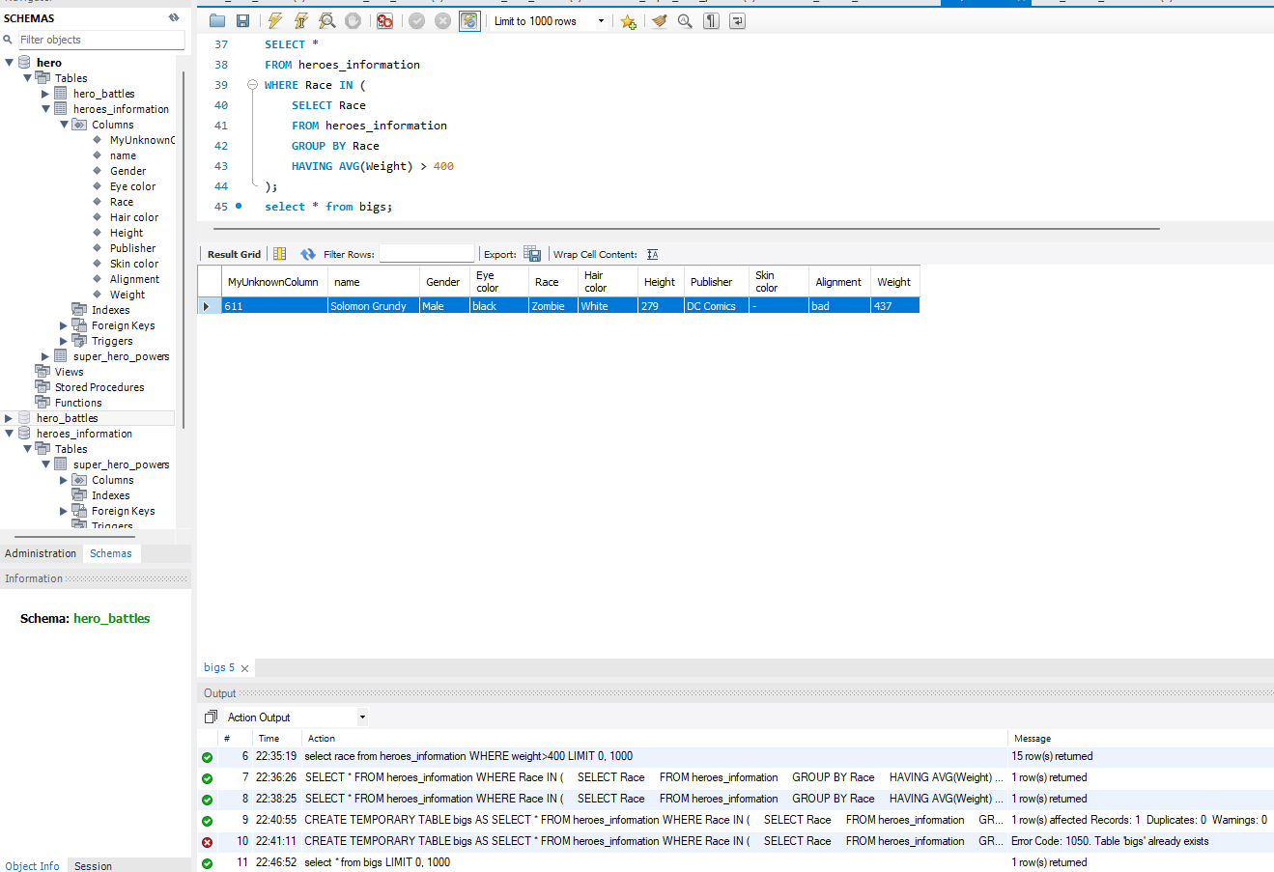

4 Write a new query that creates a view that selects the data if the publisher is Marvel Comics and if their height is above the average height.

    Bring that view up

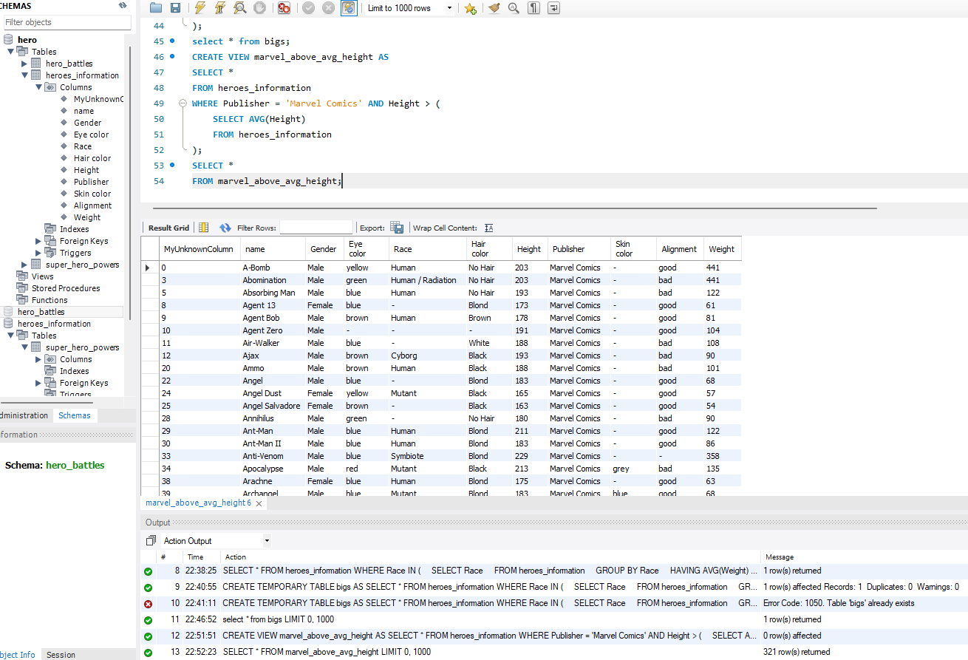

5) Now add an index to the heroes_information table on the name and Race columns.

CREATE INDEX idx_name_race ON heroes_information (name, Race);

6) Finally, create a stored procedure that selects all the data from heroes_information if they are from DC. Call it all_dc_rows.

